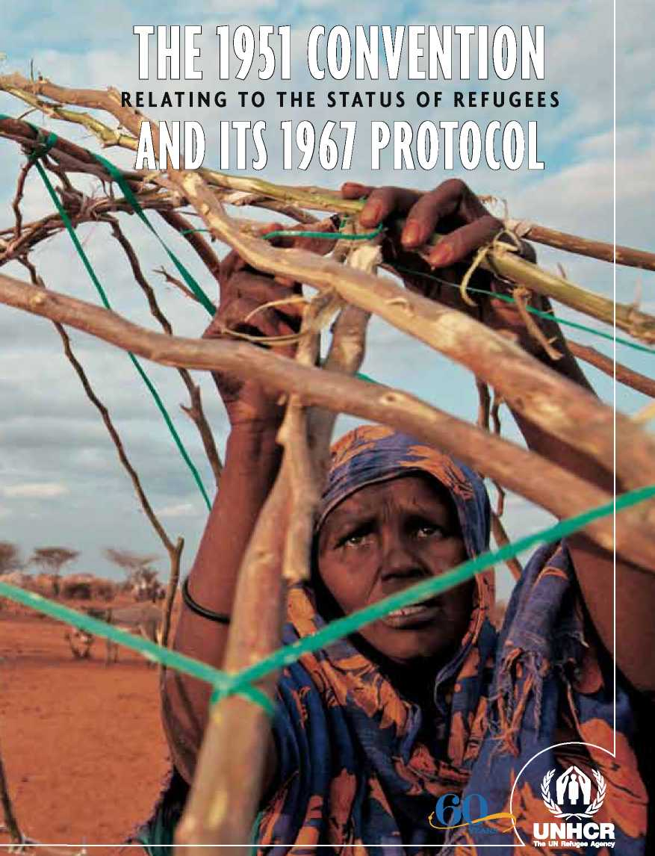

unhcr / b. bannon / ken«2011

**a persoNAL APPeAl from the UNited NAtiONS high CommissioNer for refUgees**

For more information about:

**unhCr and its work on refugees**

Visit UNHCR's website at [www.unhcr.org](http://www.unhcr.org)

You can also consult relevant *Conclusions on International Protection of UNHCR's Executive Committee* at http://www. unhcr.org/ pages/49e6e6dd6.html

**information relating to the Commemorations:**

Visit UNHCR's website at [www.unhcr.org/](http://www.unhcr.org/) commemorations

**international law relating to the protection of refugees and other persons of concern:** Visit UNHCR's Refworld at [www.refworld.org/](http://www.refworld.org/), containing a vast collection of documents relating to situations in countries of origin, protection policy and legal positions, international instruments, case law, and national legislation.

Refugees are among the most vulnerable people in the world. The 1951 Refugee Convention and its 1967 Protocol help pro­tect them. They clarify the rights of refu­gees and the obligations of the 148 States that are party to one or both of these instru­ments. Universal accession to the Refugee Convention is a valid and achievable goal. In this anniversary year of the Convention, I appeal to all non-signatory States to ac­cede to it and pledge the full support of my Office to governments to help implement its provisions.

Antonio Guterres

UN High Commissioner for Refugees

**UNHCR**

**The UN Refugee Agency**

Published by:

UNHCR

P.O. Box 2500

1211 Geneva 2

Switzerland

UNHCR, September 2011

**UNHCR / DIP*I951 CONV. / Q&A A.8 / ENG1**

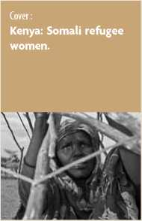

The legal framework  
for proTecTing refugees

n the aftermath of World War I (1914-1918), millions of people fled their homelands in search of refuge. Governments responded by drawing up a set of international agreements to provide travel documents for these people who were, effectively, the first refugees of the 20**th** century. Their numbers increased dramatically during and after World War II (1939-1945), as millions more were forcibly displaced, deported and/or resettled.

Throughout the 20**th** century, the international community steadily assembled a set of guidelines, laws and conventions to ensure the adequate treatment of refugees and protect their human rights. The process began under the League of Nations in 1921. In July 1951, a diplomatic conference in Geneva adopted the Convention relating to the Status of Refugees (‘1951 Convention'), which was later amended by the 1967 Protocol. These documents clearly spell out who is a refugee and the kind of legal protection, other assistance and social rights a refugee is entitled to receive. It also defines a refugee's obligations to host countries and specifies certain categories of people, such as war criminals, who do not qualify for refugee status. Initially, the 1951 Convention was more or less limited to protecting European refugees in the aftermath of World War II, but the 1967 Protocol expanded its scope as the problem of displacement spread around the world.

These instruments have also helped inspire important regional instruments such as the 1969 OAU Refugee Convention in Africa, the 1984 Cartagena Declaration in Latin America and the development of a common asylum sys­tem in the European Union. Today, the 1951 Convention and 1967 Protocol together remain the cornerstone of refugee protection, and their provisions are as relevant now as when they were drafted.

why do refugees need proTecTion?

S

tates are responsible for protecting the fundamental human rights of their citizens. When they are unable or unwilling to do so - often for political reasons or based on discrimination - individuals may suffer such serious viola­tions of their human rights that they have to leave their homes, their families and their communities to find sanctuary in another country. Since, by defini­tion, refugees are not protected by their own governments, the international community steps in to ensure they are safe and protected.

is The 1951 convenTion  
sTill relevanT in Today's world?

T

he realities of conflict, violence and persecution continue to cause displace­ment. Refugee protection remains urgently needed by those forced to leave their countries. The 1951 Convention and its 1967 Protocol are the only global legal instruments explicitly covering the most important aspects of a refugee's life. According to their provisions, refugees deserve, as a minimum, the same standards of treatment enjoyed by other foreign nationals in a given country and, in many cases, the same treatment as nationals. The 1951 Convention also recognizes the international scope of the refugee problem and the importance of international solidarity and cooperation in trying to resolve them.

The 1951 Convention has shown remarkable resilience over the last 60 years as the nature of conflict as well as patterns of migration have changed. The international system of refugee protection has helped to protect millions of people in a wide variety of situations. As long as people continue to be persecuted, there will be a need for the 1951 Convention and its 1967 Protocol.

proTecTing refugees

wiTh The 1951 convenTion

Who does The 1951 convenTion proTecT?

iS refugee proTeCTion permanenT?

The 1951 Convention protects refugees. It defines a refugee as a person who is outside his or her country of na­tionality or habitual residence; has a well-founded fear of being persecuted because of his or her race, religion, nationality, membership of a particular social group or political opinion; and is unable or unwilling to avail him— or herself of the protection of that country, or to return there, for fear of persecution (*see Article 1A(2)*).

People who fulfill this definition are entitled to the rights and bound by the duties contained in the 1951 Convention.

The protection provided under the 1951 Convention is not automatically permanent.

A person may no longer be a ref­ugee when the basis for his or her refugee status ceases to exist. This may occur when, for example, refugees vol­untary repatriate to their home coun­tries once the situation there permits such return. It may also occur when refugees integrate or become natural­ized in their host countries and stay permanently.

Can Someone be exCluded from refugee proTeCTion?

whaT is The difference beTween a refugee and a migranT?

Refugees are forced to flee because of a threat of persecution and because they lack the protection of their own country.

A migrant, in comparison, may leave his or her country for many reasons that are not related to persecution, such as for the purposes of employ­ment, family reunification or study. A migrant continues to enjoy the protec­tion of his or her own government, even when abroad.

Yes. The 1951 Convention only pro­tects persons who meet the criteria for refugee status. Certain categories of people are considered not to deserve refugee protection and should be ex­cluded from such protection.

This includes persons for whom there are serious reasons to suspect that:

• they have committed a crime against peace, a war crime, a crime against humanity or a serious non-political crime outside their country of refuge; or

• they are guilty of acts contrary to the purposes and principles of the United Nations.

whaT RighTS do refugees have under The 1951 convenTion?

The 1951 Convention contains a number of rights and also highlights the ob­ligations of refugees towards their host country. The cornerstone of the 1951 Convention is the principle of *non-refoulement* contained in Article 33. Accord­ing to this principle, a refugee should not be returned to a country where he or she faces serious threats to his or her life or freedom. This protection may not be claimed by refugees who are reasonably regarded as a danger to the security of the country, or having been convicted of a particularly serious crime, are considered a danger to the community.

Other rights contained in the 1951 Convention include:

• The right not to be expelled, except under certain, strictly defined conditions (Article 32);

• The right not to be punished for illegal entry into the territory of a contracting State (Article 31);

• The right to work (Articles 17 to 19);

• The right to housing (Article 21);

• The right to education (Article 22);

• The right to public relief and assistance (Article 23);

• The right to freedom of religion (Article 4);

• The right to access the courts (Article 16);

• The right to freedom of movement within the territory (Article 26); and

• The right to be issued identity and travel documents (Articles 27 and 28).

Some basic rights, including the right to be protected from *refoulement*, apply to all refugees. A refugee becomes entitled to other rights the longer they remain in the host country, which is based on the recognition that the longer they remain as refugees, the more rights they need.

WhaT RighTS does The 1967 proTocoi conTain?

The 1967 Protocol broadens the applicability of the 1951 Convention. The 1967 Protocol removes the geographical and time limits that were part of the 1951 Convention. These limits initially restricted the Convention to persons who became refugees due to events occurring in Europe before 1 January 1951.

doeS a refugee alSo have obligaTionS?

Refugees are required to abide by the laws and regulations of their country of asylum and respect measures taken for the maintenance of public order.

Who deTermines WheTher a person is a refugee? how is This done?

Protecting refugees is primarily the responsibility of States. This may be done by an individual or group assessment as to whether they meet the definition in the Convention. Although the 1951 Convention does not prescribe a particular procedure for the determination of whether a person is a refugee, where an individual assessment is the preferred approach, any procedures must be fair and efficient. This would require that States designate a central authority with the relevant knowledge and expertise to assess applications, ensure procedural safeguards are available at all stages of the process and permit appeals or re­views of initial decisions. UNHCR has been tasked to assist States to establish such procedures.

is The 1951 convenTion The only insTrumenT reievanT to The righTs of refugees?

No. The 1951 Convention is the only global legal instrument dealing with the status and rights of refugees. In addition to the 1951 Convention, there are several conventions and declarations that are of particular relevance in specific regions. For example, there are legal instruments on refugees that apply in Africa, Latin America and the European Union. There is also a substantial body of international human rights law that complements the rights of refugees in the 1951 Convention. States are already committed to protecting the human rights of refugees through their human rights obligations, not least the right to live in security and with dignity.

|  |  |
| --- | --- |
| **Can a CounTry ThaT has noT signed** | **The 1951 ConvenTion refuse To-** |
| **admiT a person seeking proTeCTion?** |  |

The principle of *non-refoulement*, which prohibits the return of a refugee to a territory where his or her life or freedom is threatened, is considered a rule of customary international law. As such it is binding an all States, regard­less of whether they have acceded to the 1951 Convention or 1967 Protocol. A refugee seeking protection must not be prevented from entering a country as this would amount to refoulement.

how does unhcr assisT sTaTes To

proTecT refugees?

u

NHCR is mandated by the United Nations General Assembly to seek international protection and permanent solutions for refugees. It also has the responsibility to supervise the implementation of the 1951 Convention by States Parties. States Parties are required to cooperate with UNHCR, and pro­vide relevant information and statistical data. UNHCR's role complements that of States, contributing to the protection of refugees by: y**y**Promoting accession to, and implementation of, refugee conventions and laws; y**y**Ensuring that refugees are treated in accordance with internationally recog­nized legal standards;

y**y**Ensuring that refugees are granted asylum and are not forcibly returned to the countries from which they have fled;

y**y**Promoting appropriate procedures to determine whether or not a person is a refugee according to the 1951 Convention definition and/or to other defini­tions found in regional conventions; and

y**y**Seeking durable solutions for refugees.

whaT is The link beTween unhcr and The 1951 convenTion?

UNHCR serves as the ‘guardian' of the 1951 Convention and its 1967 Protocol. The 1951 Convention expressly provides that States are expected to cooperate with UNHCR in ensuring that the rights of refugees are respected and protected.

The imporTance of accession To  
The 1951 convenTion

Why is iT imporTanT for STaTes to accede to The 1951 convenTion and iTS proTocoi?

The refugee phenomenon is one of truly global proportions, affecting not only millions of marginalized people directly but also the policies and practices of virtually every government in the world. To help tackle this problem UNHCR believes that it is necessary to broaden the base of State support for these refugee instruments, ensuring that the protection provided to refugees is more universal in scope and the burdens and responsibilities of governments are more equitably distributed and consistently applied.

When a State accedes to the 1951 Convention:

y**y**it demonstrates its commitment to treating refugees in accordance with in­ternationally recognized legal and humanitarian standards;

y**y**it gives refugees a possibility to find safety;

y**y**it helps to avoid friction between States over refugee questions. Granting asylum is a peaceful, humanitarian and legal act rather than a hostile gesture, and should be understood by the refugee's country of origin as such;

y**y**it demonstrates its willingness to share the responsibility for protecting refu­gees; and

y**y**it helps UNHCR to mobilize international support for the protection of refu­gees.



n How to accede to the 1967 Protocol?

States wishing to accede to the 1967 Protocol must follow a similar procedure as for accession to the 1951 Convention. Accession to the 1967 Protocol obliges the acceding State to apply the provisions of the 1951 Convention without any temporal or geographical limitations, unless in relation to the latter they maintain a declaration under paragraph (a) of Article 1B(1) of the 1951 Convention. A model instrument for accession to the Protocol can be found in Annex II.

n **Can a State accede simultaneously to both the 1951 Convention and the 1967 Protocol?**

Yes. In fact, most States have done so. When acceding simultaneously to both instruments, States must still make a formal declaration regarding the geographical application under 1B (1) of the 1951 Convention.

frequenTly asked ques

n How to accede to the 1951 Convention?

A State can accede to the 1951 Convention at any time by depositing a so-called “instrument of accession” with the United Nations Secretary-General. The instrument of accession must be signed by the Head of State or Government or the Foreign Minister, and is then usually transmitted through the Representative of the acceding country accredited to the United Nations Headquarters in New York. A model instrument for accession to the 1951 Convention can be found in Annex I.

When acceding to the 1951 Convention, States must make a declaration as to whether they choose alternative (a) or (b) of Article 1B (1) of the 1951 Convention.[1] Nearly all States Parties to the 1951 Convention have accepted the wider alternative and acknowledge events “occurring in Europe and elsewhere”; and almost all States that originally introduced the geographical limitation as per alternative (a) have since withdrawn it.



Tions abouT accession

n What happens in situations of State succession?

In cases where States have been disintegrated or divided in parts, the new States are in principle bound by treaties to which the predecessor State was a State Party. These new States should notify the Secretary-General as the depository of the 1951 Convention and the 1967 Protocol accordingly of their succession to these treaties. Model instruments for succession to the Convention and Protocol can be found in Annexes III and IV.

n **Can a State adopt reservations to the provisions of the 1951 Convention and the 1967 Protocol?**

In principle, reservations are permitted at the time of ratification or accession to the 1951 Convention. In accordance with Article 42 of the 1951 Convention, however, reservations may not be made to several of its fundamental provisions, namely:

•y Article 1 (definition of the term “refugee”); •y Article 3 (non-discrimination);

•y Article 4 (freedom of religion); •y Article 16(1) (access to courts);

•y Article 33 (non-refoulement); and

• Articles 36-46 (final clauses).

Upon accession to the 1967 Protocol, reservations may be made to any article(s) of the 1951 Convention, except those mentioned above. No reservations may be made to Article II of the 1967 Protocol, concerning cooperation with UNHCR.

Reservations must be compatible with the object and purpose of the 1951 Convention and 1967 Protocol and should not be expressed so broadly that it is impossible for other States Parties to determine their scope. Instead of a reservation, States can also make an “interpretative declaration”. Such declarations do not modify the legal effects of a provision, but express a State's understanding of certain aspects of the 1951 Convention or 1967 Protocol.

n Can reservations, once made, be withdrawn?

Yes. Over time, and in response to changes in circumstances, many States have withdrawn reservations made at the time of accession.





WHEREAS a Convention Relating to the Status of Refugees was adopted by the United Nations Conference of Plenipotentiaries on the Status of Refugees and Stateless Persons on the 25th day of July, one thousand, nine hundred and fifty-one, and is open for accession pursuant to Article 39 thereof;

AND WHEREAS it is provided in section 3 of the said Article 39 that acces­sion thereto shall be effected by deposit of an instrument with the Secretary­General of the United Nations;

NOW THEREFORE, the undersigned, [Title of Head of State or Government, or of Foreign Minister], hereby notifies the accession of [State concerned] to the said Convention, and declares that [State concerned] considers itself bound by alternative (b) of Article 1B(1) thereof, that is to say “events occurring in Europe or elsewhere before 1 January 1951”.

GIVEN under my hand in this day of two

thousand and .

[Public Seal and

Signature of Custodian, if appropriate]

[Signature of Head of State Head of Government or Foreign Minister]

WHEREAS the Protocol Relating to the Status of Refugees was adopted by the General Assembly of the United Nations on the 16th day of December, one thousand, nine hundred and sixty six, and is open for accession pursuant to Article V thereof;

AND WHEREAS it is provided in Article V that accession thereto shall be effected by deposit of an instrument with the Secretary-General of the United Nations;

NOW THEREFORE, the undersigned, [Title of Head of State or Government, or of Foreign Minister], hereby notifies the accession of [State concerned] to the said Protocol.

GIVEN under my hand in this day of two

thousand and .

[Public Seal and

Signature of Custodian, if appropriate]

[Signature of Head of State Head of Government or Foreign Minister]

WHEREAS the Convention Relating to the Status of Refugees, done at Geneva on 25 July 1951, was ratified by [Former State Party];

AND WHEREAS the Government of [Successor State] has examined the said Convention;

THE GOVERNMENT of [Successor State] declares that it regards the said Convention as continuing in force for [Successor State] and hereby succeeds to the same;

NOW THEREFORE, the undersigned, [Title of Head of State or Government, or of Foreign Minister], hereby notifies the succession of [Successor State] to the said Convention, and declares that [Successor State] considers itself bound by alternative (b) of Article 1B(1) thereof, that is to say “events occurring in Europe or elsewhere before 1 January 1951”.

GIVEN under my hand in this day of two

thousand and .

[Public Seal and

Signature of Custodian, if appropriate]

[Signature of Head of State Head of Government or Foreign Minister]

Annex iv

MODEL INSTRUMENT OF SUCCESSION  
TO THE PROTOCOL RELATING TO  
THE STATUS OF REFUGEES OF 1967

WHEREAS the Protocol Relating to the Status of Refugees was adopted by the General Assembly of the United Nations on the 16th day of December, one thousand, nine hundred and sixty six, and was ratified by [Former State Party];

AND WHEREAS the Government of [Successor State] has examined the said Protocol;

THE GOVERNMENT of [Successor State] declares that it regards the said Protocol as continuing in force for [Successor State] and hereby succeeds to the same;

NOW THEREFORE, the undersigned, [Title of Head of State or Government, or of Foreign Minister], hereby notifies the succession of [Successor State] to the said Protocol.

GIVEN under my hand in this day of two

thousand and .

[Public Seal and

Signature of Custodian, if appropriate]

[Signature of Head of State, Head of Government or Foreign Minister]

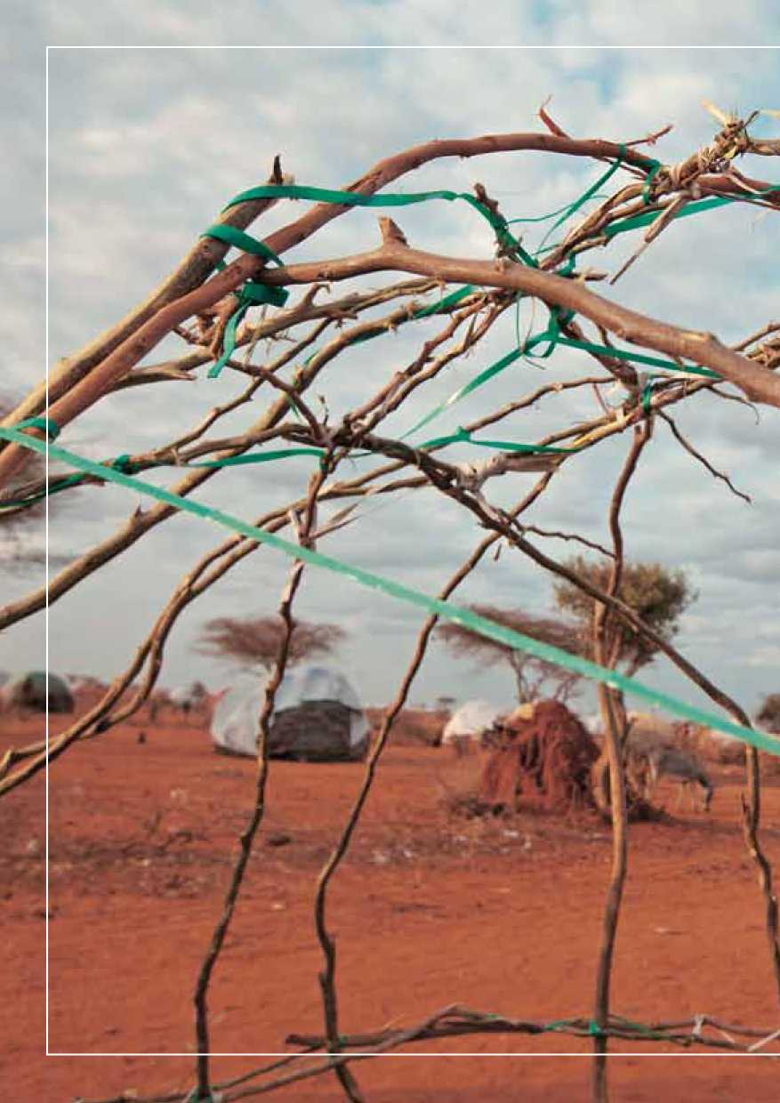

1. Article 1B (1) states: “For the purpose of this Convention, the words ‘events occurring before 1 January 1951' in Article 1, Section A, shall be understood to mean either:

   (a) ‘events occurring in Europe before 1 January 1951' or

   (b) ‘events occurring in Europe and elsewhere before 1 January 1951',

   and each Contracting State shall make a declaration at the time of signature, ratification or accession, specifying which of these meanings it applies for the purpose of its obligations under this Convention.”